INTRODUCTION TO CLOUD

Cloud
Cloud is a sharing of resource from a remote location via internet on pay as you go basis.
Cloud Computing
- Cloud computing is the delivery of computing services over the Internet.
- Provides on-demand access to servers, storage, databases, and networking.
- Pay-as-you-go pricing model.
- No need to manage physical hardware.

Cloud computing is the on-demand delivery of services like the servers, storages, databases, networking and also the other IT resources access through the cloud service platform via internet on pay as you go basis.

Major Cloud Providers
- Amazon Web Services (AWS)
- Microsoft Azure
- Google Cloud Platform (GCP)

TRADITIONAL IT VS CLOUD
Traditional (On-Premise)
- Requires Purchasing physical servers
- High initial investment (capex)
- Manual maintenance & upgrades
- Limited scalability
Cloud Computing
- No need to buy hardware
- Instant resource provisioning
- Low upfront cost (opex)
- Auto-scaling & flexibility
- High availability & reliability

CHARACTERISTICS OF CLOUD COMPUTING
- On-Demand Self-Service ----> Users can create resources anytime
- Broad Network Access ------> Accessible from anywhere via internet
- Resource Pooling ------> Shared resources among users
- Rapid Elasticity ---------> Scale up/down quickly
- Measured Service (Pay-as-you-go) -----> Pay only for what you use

CLOUD SERVICE MODELS
IaaS (Infrastructure as a Service)
- IaaS provides basic infrastructure like servers, storage, networking, and virtualization.
- While the applications, data, runtime, middleware & OS should be manageable by the user
- Example: AWS EC2

PaaS (Platform as a Service)
- Pass provides the entire ready to use platform to directly run the code
- These platform Generally useful for the developers to build and deployed their applications
- While the applications and the data only manageable by the user
- Example: AWS Elastic Beanstalk / aws lambda

SaaS (Software as a Service)
- Saas gives u the entire ready software over the internet
- All the things in these should be manageable by the provider
- Example: Gmail, Office 365

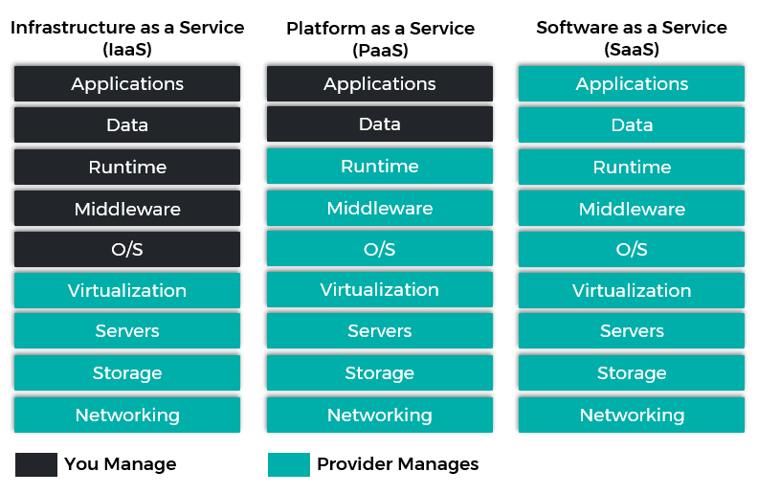
CLOUD DEPLOYMENT MODELS
Public Cloud
- Public cloud is a cloud environment where services are provided over the internet and shared by multiple users.
- Resources are shared among many organizations
- Managed by a third-party provider
- Example: AWS
Private Cloud
- Private cloud is a cloud environment dedicated to a single organization only.
- Provides high security and control
- Infrastructure is not shared with others
- Can be hosted on-premises or privately managed

Hybrid Cloud
- Definition: Hybrid cloud is a combination of public cloud and private cloud working together.
- Allows data and applications to move between both clouds
- Gives flexibility and better performance
- Used by most companies for balance of security and cost
Simple Words:
- Public → Everyone uses
- Private → Only one company uses
- Hybrid → Both combined

IMPORTANCE OF CLOUD IN DEVOPS
- Enables Fast deployment
- Automation support
- Integrates easily with CI/CD pipelines
- Provides Scalable infrastructure
- Cost optimization (pay as you go)
- Offers Global availability

VIRTUALIZATION

VIRTUALIZATION
- Virtualization is a technology of splitting the physical resource into as many as logical resources as needed.
- It allows multiple virtual machines (VMs) to run on one physical system.
- Virtualization is a technology that transforms hardware into the software -based resources.
- Helps in better resource utilization and cost savings.

HYPERVISOR
- Hypervisor is a software that creates the space and runs the virtual machine.
- we use two operating system at a same time with the help of hypervisor.
- It controls and allocates CPU, memory, and storage to VMs.

TYPES OF HYPERVISORS
- Type-1 hypervisor (Bare-metal hypervisor)
- Type-2 hypervisor (Hosted hypervisor)

Type-1 Hypervisor (bare-metal hypervisor)
- Type-1 hypervisor is also called as bare-metal hypervisor.
- It’s a hypervisor that directly runs on the host hardware. also known as hardware level virtualization
- a guest os runs on another level above the hypervisor.
- Type-1 hypervisor acts as their own operating system.
- it has the direct access to the host hardware and resources.
- More secure and reliable than Type-2.
- Used in data centres and cloud environments.
- example: (Microsoft Hyper-V, VMware ESXi)

Architecture of type-1 hypervisor
- O.S (centos/ubuntu/windows)
- VM
- Hypervisor
- Hardware

Type-2 Hypervisor (Hosted hypervisor)
- type-2 hypervisor is also called as hosted hypervisor.
- It’s a hypervisor that runs on the host O.S. also known as os-level virtualization.
- it does not have the direct access to the host hardware and resources.
- less secure (if there is any error in the hardware or the O.S then the whole VMs can crash)
- example: (Oracle VirtualBox, VMware Workstation)

Architecture of type-2 hypervisor
- O.S (centos/ubuntu/windows)
- VM
- Hypervisor
- Host OS
- Hardware

